Attendees: Adilho Souza |Tom Kenyon |Craig Rose | Mike Higgins | George Garcia | Paul Horvath | Marty Nicholson | Zack Ransom | Mike Martel Steve Kirgakosa | - 10 total [Attached 2]
Next Dad’s Club meeting: April 27th
New Attendees: No
Joined Via Meets. No
The meeting was Called to order by Steve Mike Martel at 8:03p,
1. Opening Prayer: Craig Rose
2. Approve Meeting Minutes: - February (Steve and Tod - Minutes from Craig notes, the secretary was not presented)
3. Executive Report: Mike Martel
- The parade will occur as usual, and Dad’s club will support doing the grill.
- During teacher’s week, it was a potential that the Dad’s Cloud could cook since it is in the middle of the week and voluntary; another potential is to have pizza (May 6-10).
  - Marty will support it.
- $5000 to cover the expense of the garage roof fixed. This topic was approved.
- $1000 was approved for the Youth Group to support a trip to the national Eucharistic conference in Indianapolis. [attached 3]
- Election committee - Zack Rassam (Chair of the commission & Steve Kiryakosa.
  - The communication must be done as early as two months before per the by-law.
- Dad’s and daughter's dance _ on April 19th - Zack suggested a table from the Dad’s club.
Approval: -Marty and Paul

4. Treasurer Report: Mike Higgins
- Total balance: $ 23,310.13
- Checking: $ 3,907.00
- Saving account: $ 72,811.00
- Attached 4
- We should plan and define some projects with the savings accounts.
Approval: Tod | Jared

5. School Board Reports: Steve Kyriakosa
- There was no meeting last month.
- The Tuesday after the spring break (April 9th)

Approval: Tod | Jared
6. Athletic Report: Jared Jonckheere
- Table for next month.

Approval:
7. Robotics: Craig Rose
- The Robotics is looking for a firm space for four months to avoid the necessity to be assembled and reassembled every time.
- Paul Horvath will check for potential space.
Approval: -
8. Standing Committees:
- Table for next meeting.
Approval: -
9. Golf Committee: John Prior
- Table for next meeting.

10. Membership Committee: Zack Rasam
- Table for next meeting.
Approval: -
11. Christmas tree Sale:
- Table for next meeting.
Approval: -

12. St. Patrick’s party: Marty Nicholson

Please see the attached 1 with the details.
It was a successful event, comments by several team members.
Approval: -
13. Fish Fry: Paul Horvath
Paul is pleased with the teamwork, and we have potential profit. And in general, it was a success, thanks to George's support.
Approval: -
14. Grant Committee:
- Table for next meeting.
Approval: -
15. New Business:
- No
Approval: -
16. Close prayer:
- Brant’s aunt passed away on fire.
- A Marty friend was not able to have the surgery and was waiting for a long time.
- Craig's wife's aunt has cancer.
- Adilho’s mom is facing a second case of pneumonia, and she has a good recovery.

The meeting Adjourned at 9:15 p.m.
End of Document Adilho Souza

Attached 1
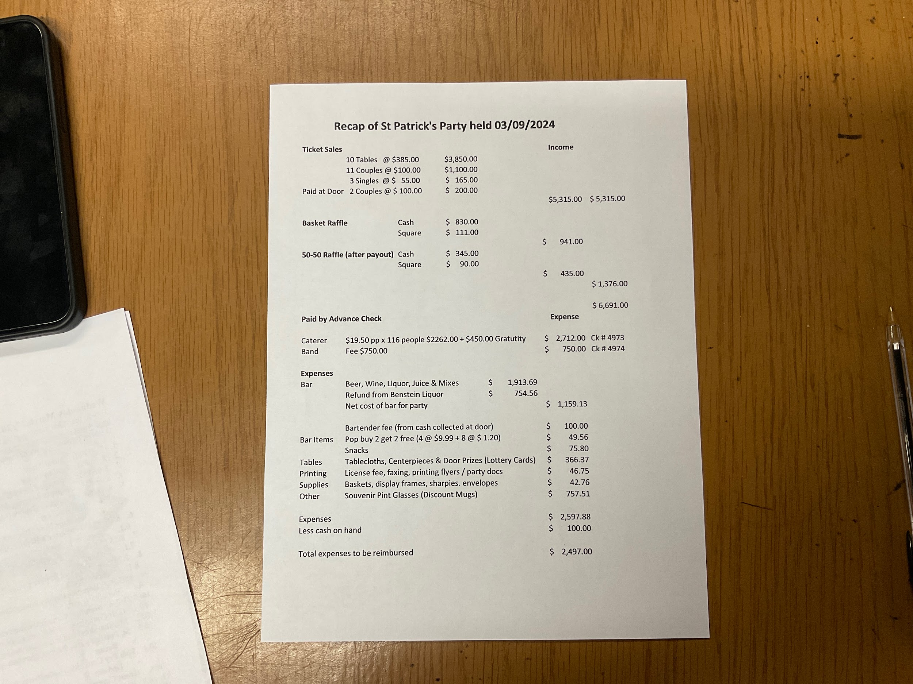

Attended 2
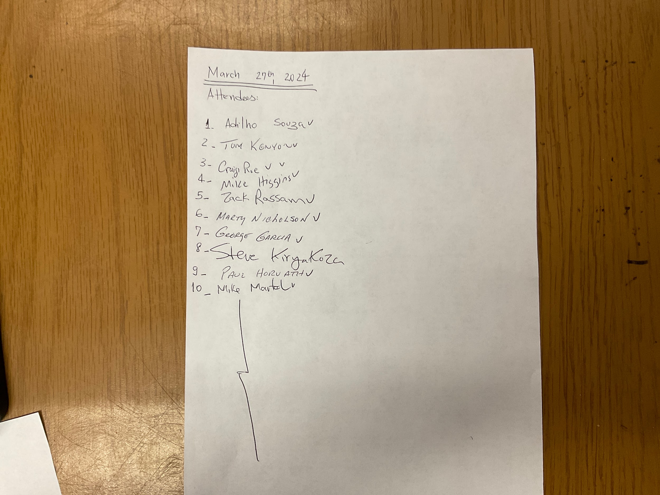

Attached 3
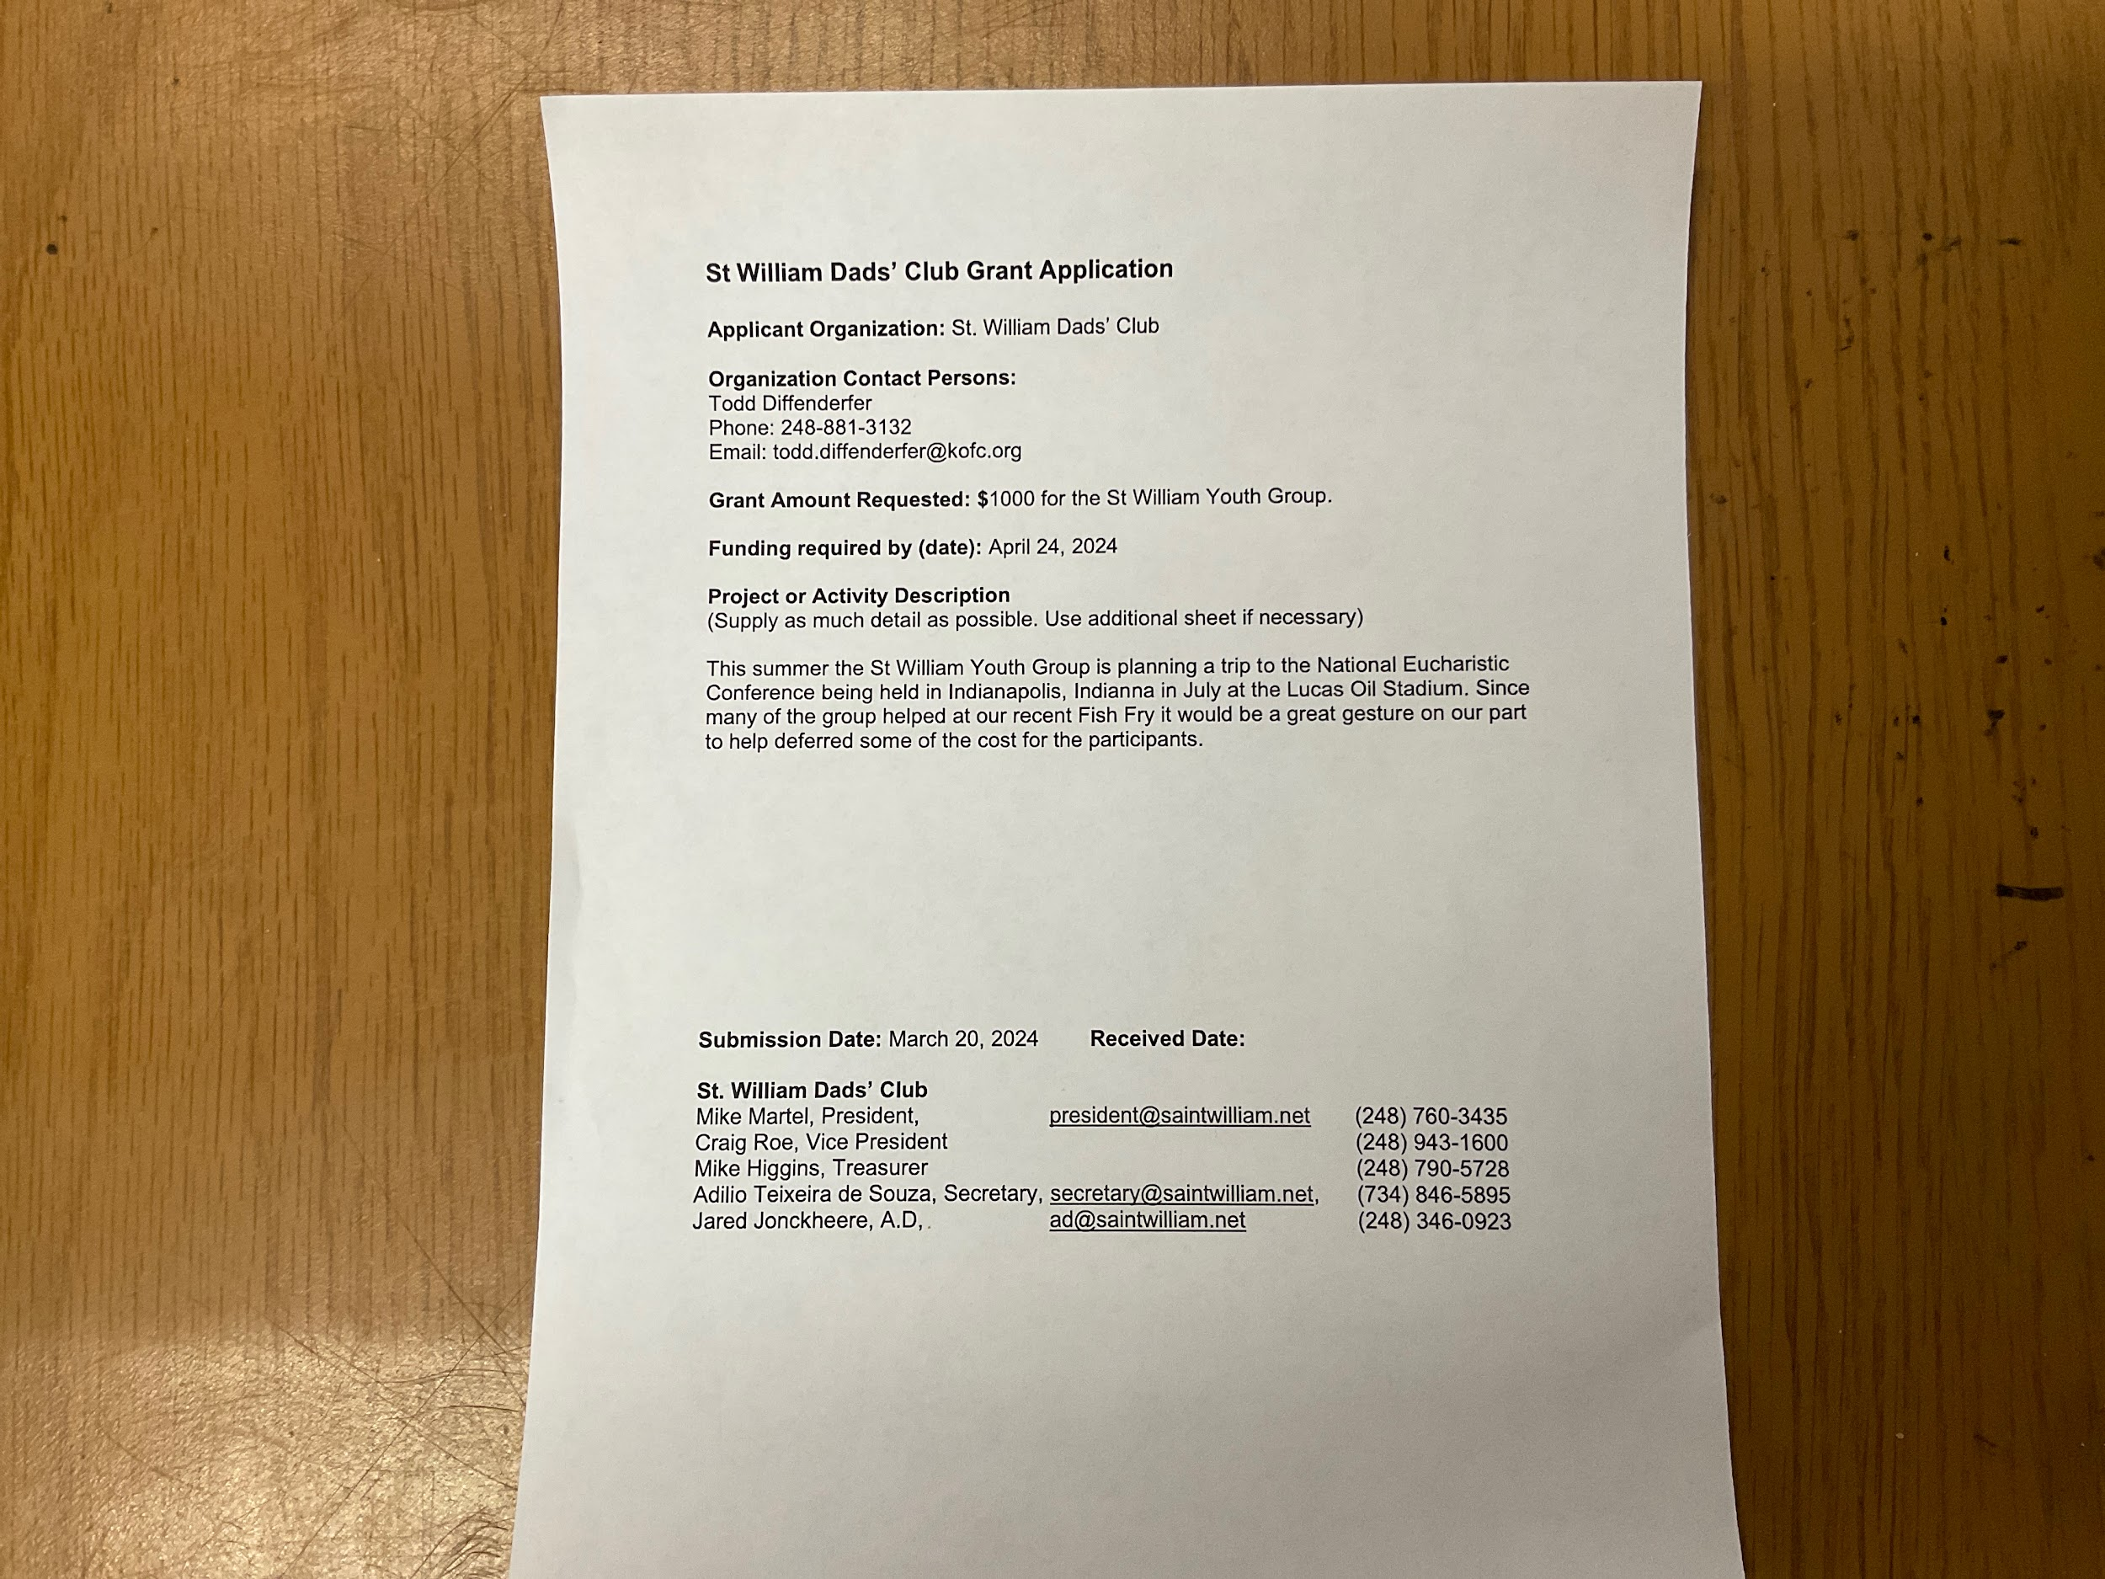

Attached 4

